Recruit local organizations to become partners and join the Read Aloud 15 MINUTES Movement

Organizing an effective local campaign requires bringing together all the organizations in your area that reach parents with young children. It takes one committed person, by way of telephone calls and follow-up emails, to bring together the forces already in place to reach young families with the Read Aloud 15 MINUTES messaging and campaign materials. As an example, in the Springfield, Missouri area, Librarian, Nancee Dahms-Stinson, has brought together the Springfield-Greene County Library, United Way of the Ozarks, Mayor’s Commission on Children, Child Care Aware of Southern Missouri, Community Partnership of the Ozarks, Springfield Public Schools, Lighthouse Child and Family Development Centers, Missouri State University Child Development Centers, Ozark Area Head Start, OTC Early Childhood Center, and Parents as Teachers.

TEMPLATE

Dear {First Name}:

Read Aloud 15 MINUTES and more than 1,500 partners are working to spread one simple, powerful message: Read Aloud 15 MINUTES. Every child. Every parent. Every day. Join {Your Organization} and help foster a 15 MINUTES movement in our community.

The Read Aloud 15 MINUTES National Campaign has three, month-long pulses each year. For each pulse, partners will receive great new, easy to use, content to share with the parents of children they reach.

Sign up today at www2.readaloud.org/becomeapartner. It’s free!

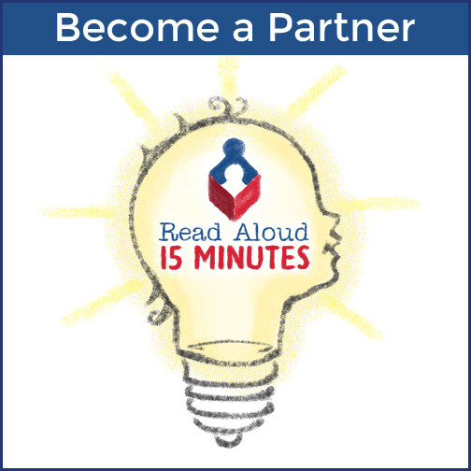

When every child is read aloud to for 15 minutes every day from birth, more children will be ready to learn when they enter kindergarten, more children will have the literacy skills needed to succeed in school, and more children will be prepared for a productive and meaningful life after school.

Best regards,

{Your Name}
{Your Organization}

About Read Aloud

Read Aloud 15 MINUTES is a non-profit organization that is working to make reading aloud every day for at least 15 minutes the new standard in child care. When every child is read aloud to for 15 minutes every day from birth, more children will be ready to learn when they enter kindergarten, more children will have the literacy skills needed to succeed in school, and more children will be prepared for a productive and meaningful life after school. For more information, visit: www.readaloud.org.

